**The TMDb database**

Exploring [The Movie Database](https://www.themoviedb.org/) – an online movie and TV show database that houses some of the most popular movies and TV shows at your fingertips. The TMDb database supports 39 official languages used in over 180 countries daily and dates back all the way to 2008.

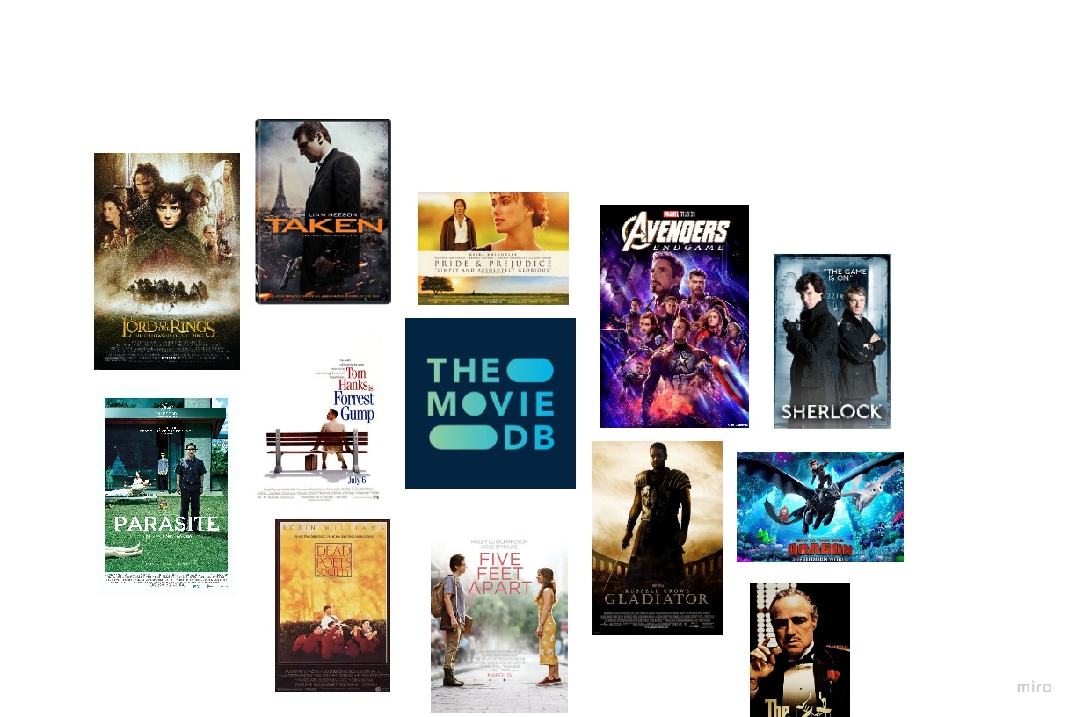

Below is an Entity Relationship Diagram (ERD) of the TMDb database:

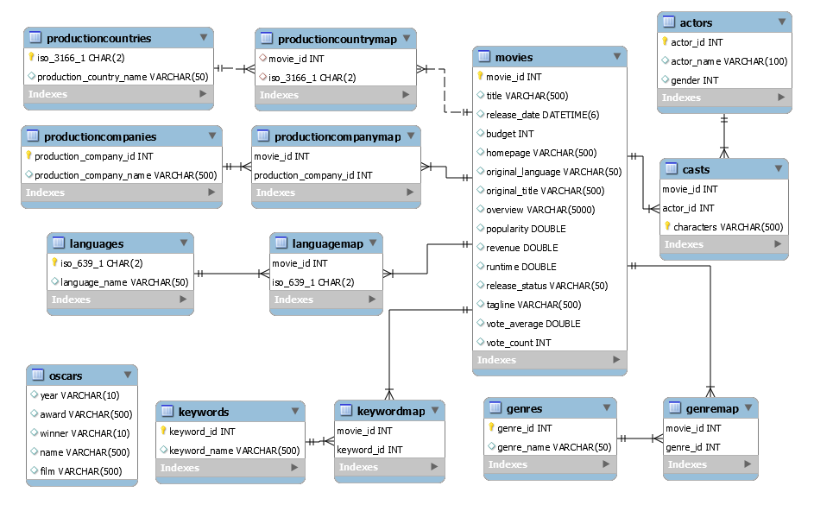

As can be seen from the ERD, the TMDb database consists of 12 tables containing information about movies, cast, genre, and so much more.

Let's get started!